Hawaii Acoustic Music Workshop March 6-12, 2011
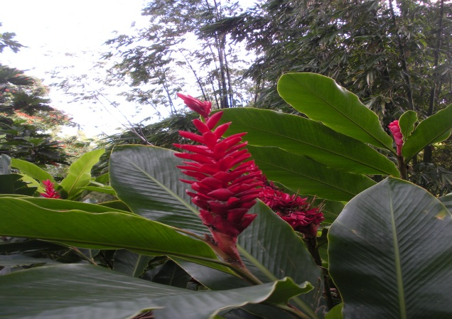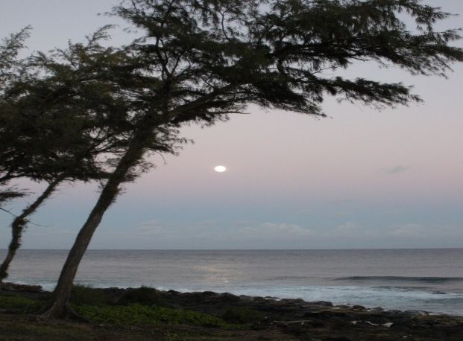
A music workshop for adults (or music loving youth with adult supervision) on the Big Island, at Kalani Oceanside Retreat Village (http://www.kalani.com) in Pahoa, Hawaii.
Music Workshop Dates:
Sunday Evening, March 6 through Saturday Morning, March 12, 2011
General Program:
-All levels singing classes using multicultural music, intermediate blues and folk guitar, intro to keyboard, special classes by request: Anne Weiss
-Beginning Guitar, open tunings: Eric von Beck
- Ukulele: TBA
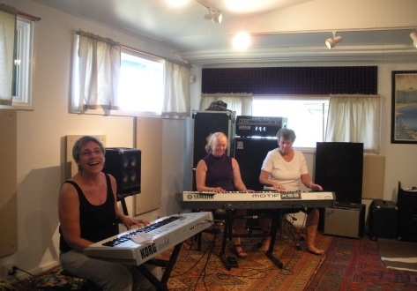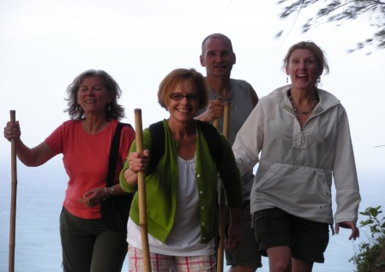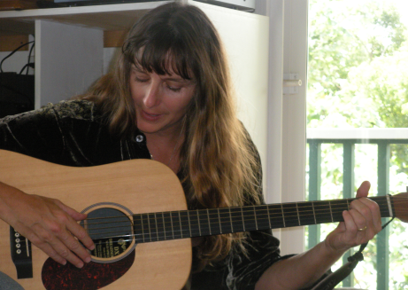
Activities and events: Volcano visitations, Natural warm springs, hike and beach excursions,
Teacher performance, Student performance (optional- no pressure!), Jam-on-the-Beach, more!
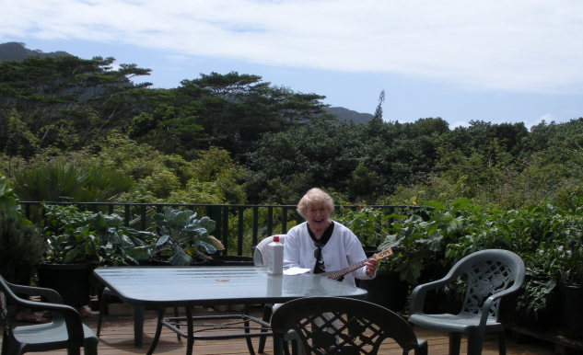 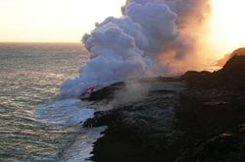

Hawaii Acoustic Music Workshop (cont.)
FAQ:
Can anyone come, even if they've never played an instrument and/or can't carry a tune in a bucket (yet)? YES!
Price:
$550 (includes all classes and group activities). To reserve your spot in the music workshop, please send an e-mail (likapika@aol.com) and a check to:
Anne Weiss 7320 SE Mill Street, Portland Oregon 97215
Additional Costs:
You are welcome to swim or row to Hawaii (you would be SO buff!), otherwise you'll have to purchase a flight. I have been seeing some great deals! One place to look is www.cheaptickets.com.
We’ll be staying at Kalani Oceanside Retreat Village, which has a pool and Jacuzzi, is minutes from the beach, is gorgeous, and serves incredible organic food three times a day! Options vary from tenting to rent-your-own-tree-house, but your cost can be as low as $60/day. Please make your reservation here: http://www.kalani.com (800) 800 6886 toll-free, US & Canada
Transportation:
Kalani has a shuttle, $65 for one person, $45 for each additional person. You are welcome to rent a car if you want extra autonomy, and the island also has taxis (several companies). We’ll make every effort to coordinate rides!
Since this is only the second year of the workshop, it is likely to be intimate, which means a great teacher to student ratio, and flexibility about what classes we run and which activities we do (your request here!).
Please reserve your spot ASAP by contacting Anne Weiss at 503-232-1720; or likapika@aol.com.
More info: www.anneweiss.com

Eric von Beck and Anne Weiss

